**Mathematics and Numeracy**

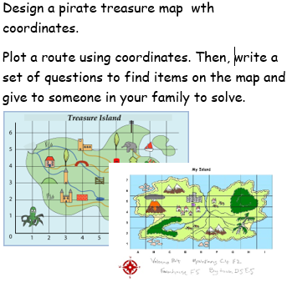 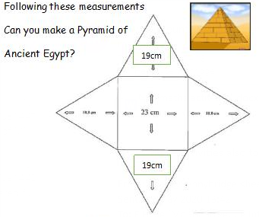 

**Language, literacy and communication**

Listen/read the story, ‘Dear Teacher’ by Amy Husband.

Task – Can you make a list of the things that Michael likes and dislikes? Maybe you could then make a list of the things that you like about school and see which are the same?

Task – Choose one of the adventures Michael has been on. Can you retell it as a story/postcard/comic strip?

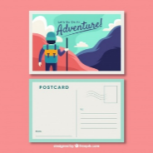

Task –

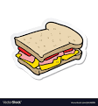

**Health and Wellbeing**

Task – Design and make Michael:

1. Your favourite sandwich / wrap
2. A healthy sandwich to get to Everest
3. A wild and wacky sandwich with strange fillings!!

Task – Michael goes to lots of countries. Can you design an obstacle course for each country he goes to? For each country, you could do a different activity i.e. Egypt = 10 jumps.

Task –

**Science and Technology**

Task – Make a model of the solar system Michael travels through on his mission to space. You could use any materials to help make this.

Task – In the story Michael flies a plane. Can you design and make an aeroplane? Can you make it fly? How far did it travel?

**Dear Teacher by Amy Husband**

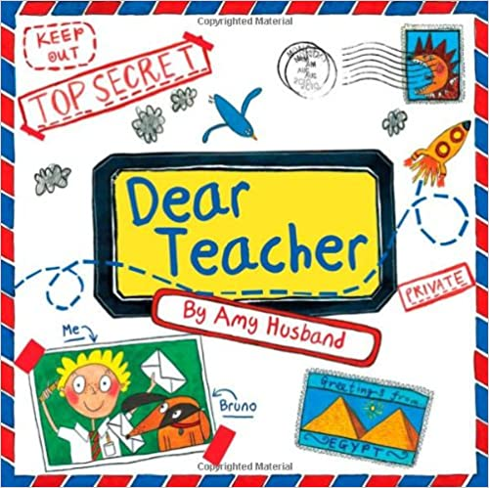



**Humanities**

Task – Michael goes to many countries in the story. Choose one and then create a TV report about what happened there.

Task – Imagine you were packing a bag/rucksack for an expedition. What would you need for the adventure? You could draw and list or photograph your rucksack.

**Expressive Arts**

Task –Bruno used a plain blue snow board to come down Mount Everest. Can you design a cool snowboard for Bruno the dog?

Task – Create a space scene that Michael and Doug may have seen from the rocket. You could use different art materials.

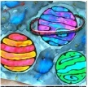

Healthy, confident individuals.

Ethical, informed citizens.

Ambitious, capable learners.

Enterprising, creative contributors.